|  |  |
| --- | --- |
| **Ex.No:4** | **Finding Maximum number in the list** |
|  |

***Aim:***

To develop a python program to find maximum number in the list without using inbuilt functions.

***Algorithm:***

|  |  |
| --- | --- |
| **Step 1:** | Start Process |
| **Step 2:** | Get a list of numbers from user and store id alist |
| **Step 3:** | Get first element from the list and assume as max |
| **Step 4:** | Get next element from the list and compare with max |
| **Step 5:** | If element is greater than max then assign max as element |
| **Step 6:** | Else don’t change the max and goto Step 7 |
| **Step 7:** | If all the elements are compared display max and goto step 9 |
| **Step 8:** | Else goto Step 4 |
| **Step 9:** | Stop Process |

**Flow Chart:**

**Pseudo Code:**

START

READ alist

ASSIGN max = alist[0]

WHILE no more element in the list

element = next element

IF element is greater than max THEN

max = element

END IF

END WHILE

PRINT "Maximum in the list" ,alist,"is:",max

STOP

**Program:**

alist = []

print ("enter any 5 numbers")

for i in range(5):

data = int(input())

alist.append(data)

max = alist[0]

for element in alist:

if (element > max):

max = element

print("Maximum in the list" ,alist,"is:",max)

**Output:**

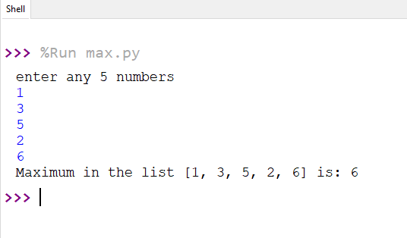

***Result:***

Thus the program to find the maximum number in the list was developed and tested successfully.